Meeting Notes

Date of meeting: 16/01/2020
Members present: Jarrad, Spencer, James, George, Nabil
Length of meeting: 1:30hrs

What was done last week?:
- Spencer asked Simon and received answers relating to the development of the game engine
- George cleaned half of the code which was set

What wasn’t done last week?:
- Finishing the game engine features

What did we discuss this week?:
- We decided that a 3D game engine will give us more marks and wouldn’t limit us too much in terms of complexity
- We tussled for a while about which game was the best. We considered everyone’s opinions and didn’t just outvote someone if they were strongly for or against an idea.
- The game we decided was a top-down’ish tank game where the player traverses a map and is attacked by AI tanks. There are obstacles which the player can use to dodge bullets. We discussed some ideas relating to multi-player but decided this was too far off to set anything in stone.
- We allocated roles as shown in the diagram below. This was more of a guideline than a decision, as certain members of the group will need help in some areas and so there will be cross-over.

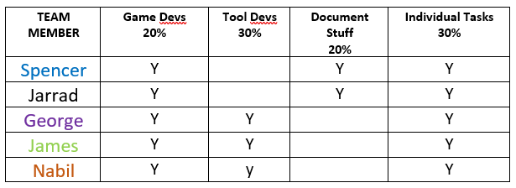

What are we going to do this week?:
- Decide which 3D physics engine to use
- Re-structure the file system so it’s better organized
- Clean the code
- Decide on what namespaces to use and implement them
- Implement a profiler (with macro & add it to its own namespace)
- Implement Uniform Buffers & any other rendering additions
- Pick an individual task that isn’t too simple & research how to implement it
- Make a Game Design Documentation
- Research Model Loading

Date of next meeting: 23/01/2020

